Republic of Malawi
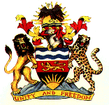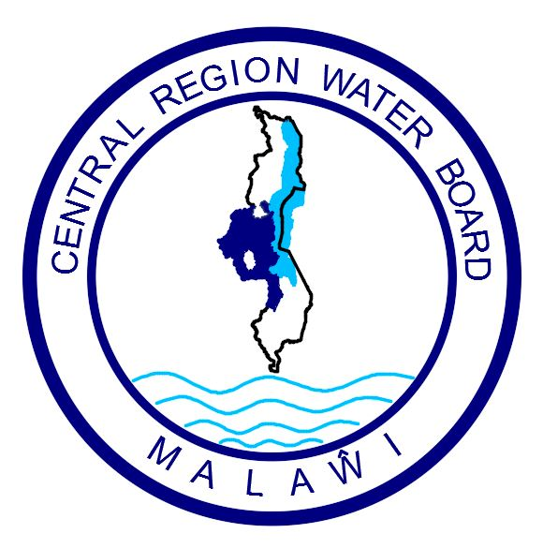

Ministry of Water and Sanitation | Central Region Water Board

Invitation For Bids - National Competitive Bidding (NCB)

Date of Issue: 09.08.2023
IFB Title: Supply and Installation of Solar Pumping System at Chitenje Plant in Nkhota-kota

IFB Number: CRWB/W/KK/23

- The Central Region Water Board has received some funds from Malawi Government through the 2023-24 National budget allocation under the Public Sector Investment Programme (PSIP) and intends to apply part of the funds towards payments under the procurement contract for Supply and Installation of Solar Pumping System at Chitenje Plant in Nkhota-kota.

The works comprise of Supply and Installation of Solar Pumping System, Civil Works, Testing and Commissioning.

- The Board now invites sealed bids from eligible and qualified bidders who must be registered with National Construction Industrial Council (NCIC) in the 500 Million Malawi Kwacha or above Civil Works category.

- Bidding will be conducted in accordance with the open tendering procedures contained in the Public Procurement Law and Regulations of the Government of Malawi.

- Interested eligible bidders may obtain further information from and in respect of bidding documents at the address at (10) (a) Attention: The Acting Procurement and Disposal Manager.

- A complete set of Bidding Documents in English may be purchased by interested bidders upon payment of a none refundable fee of MWK10, 000 (Ten Thousand Malawi Kwacha) by cash or Bank Certified cheque payable to Central Region Water Board.

- Bids must be delivered and deposited in a Tender Box that will be located at the Reception on or before 14.00 hours on 07th September 2023 clearly marked with Invitation for Bids Number (IFB No), as indicated above.

- Bids will be opened at Central Region Water Board Conference Room in the presence of bidders` representatives who may choose to attend on 07th September 2023 at 14.00 hours’ local time. Late bids will be rejected.

- Site visit and pre bid meeting will not take place.

- Central Region Water Board reserves the right to reject any or all bids and is not bound to accept the lowest or any other bidder.

- Addresses referred to above are:

- For Inspection, Clarifications, and Purchase of Bidding Documents:

Attention: Mr. Time Nyalapa – Acting Procurement and Disposal Manager
Central Region Water Board Offices
Area 4, Murry Road
Opposite Immigration Offices
Private Bag 59
Lilongwe
Malawi
Phone No: +265 (0) 310002128
Cellphones: 0999 203 621 / 0888 903 621
Email: crwb@crwb.org.mw / tnyalapa@crwb.org.mw

- For Submission of Bids:

The Chief Executive Officer
Attention: Internal Procurement and Disposal Committee
Central Region Water Board
Area 4, Murry Road
Opposite Immigration Offices
Private Bag 59
Lilongwe
Malawi

